LSImmersiveLife Visual Design Documentation

The UI Visual Design of the LSIMMERSIVELIFE should follow the documented visual design by the project creator to follow the exact UI Design Preference accordance to the Owner of the Project and have a proper reference and followance of UI design of the Gameplay in the Project Codes. The Several Project Files has its own several Design UI and specific UI Design to maintain cleanliness and organized mapping of the Project to have the Workspace Project follow the documented visual design and what it should really look and consists of and player visually able to navigate immersively and easily but great design ui and navigation

Firstly, the main navigation in the Main UI named LSimmersiveLifeMainUI has fall the main face of the gameplay UI, Only Consists :

Native Title
Secondary Native Title

LSIMMERSIVELIFE
Immersive Life in Los Santos

Then Native Menu Title only consists the Main UI of

Roleplay
Authority
Customization
Settings
Developer

That's the only simple but immersive design of the Los Santos Immersive Life Main UI of the Gameplay Project. The Design Color and Font Text and Color can be customizable under Settings File.

Native Menu of "Roleplay"

Roleplay
Roleplay only consists of a selection of roleplay when clicking the Roleplay Menu. It will fall under the Roleplay File which is Main UI will call Roleplay File to have a design ui and logic of selection of roleplay logic in Roleplay File. Police Core File will manage and command the Main UI to access the Roleplay Selection and Roleplay File will have a selection roleplay logic.
It designed
Main : Roleplay
Secondary title : Select your Immersive Life Roleplay
> Los Santos Citizen
> Gang Turf Leader
> Los Santos Police Authority

Then, when Roleplay File triggered by the User which is selecting a gameplay roleplay then Police Core will command its authority role file.

Native Menu of "Authority"

This is Authority in the Main Menu UI will access and commanded from Police Core and Police Core will call the Roleplay File to select a role then Police Core will have commanded an Authority File. So this Authority Fie is main gameplay storage when selecting each Role like Police Core, Citizen Core and Gang Leader Core. And its Police UI and Citizen UI or Core UI And Game Core will command the Authority to show the Police UI if Police Role is selected. So Authority File will show the Main Gameplay Logic of the Role. The Design Visualize will be

Main Title: Authority Role
And Secondary: Selected Gameplay Role.

There should not have a "open a Gameplay or Open the Selected Role" to prevent multiple clicking menu. So Authority File is the Storage of each Role Gameplay UI. to access the Gameplay Logic easily, So, Authoriry File will command the Roleplay File when User select specific Roleplay then when selected Role Play is triggered by User, Authority File will access a Core File and Core UI File to show storages of gameplay logic of selected core, if Police Core selected. Police Core will access the Police UI File and show the main gameplay logic in the Authority Menu when Clicking Authority Role inthe Main Game UI. So a Police in Roleplay is triggered, Main Role Gameplay can be access easily through AuthorityFile so Authority File is the Storage of Gameplay of each role and Authority Role Menu in Main UI will access those. So no,” Open a Gameplay or Open Selected Role”. Authority File will call its selected Role UI File, if Police UI, LSPDPOLICEUI file will show the design and main selection of police gameplay. And Police Core will command the Police UI to access through, gameplay UI then ultimately shows gameplay settings and each Logic File will be commanded through Police Core File

So Authority File UI Visualize Design only shows

Main Title is Authority Role
Secondary title is Immersive Gameplay Role

The Gameplay Role UI File is storage inside the Authority Role File, As not selecting any Role yet. The Authority File will show a message only

"Select a Role Gameplay in Role Play Options"

If it is Impossible to show a Police UI in Authority File without selecting another like "Open A Gameplay Role" In Authority File then clarify the C# Method of Designing UI in Game.

Native Menu of Customization : Customization consists of the HotKeys of the GamePlay Selected Role and it is handled inside the Hotkeys File and it will be wide enough collection of hotkeys used in the gameplay logic and the current deployment has foundation. And making sure that it can adapted to MainConfig File and creating a honkeys config and configurable inside game and the Main XML of Immersive Life File. And savable and configurable and automatically trigger the hotkeys used of keys in gameplay

Main Visualization Design :

Acceptance/Agree: Y
Reject/Disagree: N
Investigate : I
Dispatch Interaction and Patrol Interaction : E
Dispatch Menu: D.
Request Prisoner Transport : R

NPC Menu : G
Back Up Menu : B
Reset Police Runtime : F10

It will automatically set the configuration In-game and plus updated configuration rather than putting “save control changes” in game to prevent the forgotten to update so when a player set its own configure keys. In-game and MAIN XML it will automatically save, and can initiate a response message “Dispatch Interaction Keys set to E”
The UI Design and Logic of collecting of the Hotkeys through gameplay handled by the HotKeys File and then configurable logic by Main Config File will take from HotKey and input and configurable into to the Game Main XML.

Native Menu “Settings”

Settings consists of collections of in-game collections configurable gameplay behavior settings and can be configured and controlled in-game and then only collected through main universal XML that located inside the scripts under the DLL extension of LSImmersiveLife
The Design UI Logic and Configurable Settings in Logic should be Handled in LSSettings.CS and as well as easily accessible and configure through game and the Design should be the value-typing base and every configurable amount-based settings should only typing a value in-game and every limit, amount based and number-based settings should type a value in-game and saved properly into the Universal Main XML. Otherwise using the blue slider thingy is not configuring anything in game and the conditions of true or false settings could be designed of check and uncheck just like the foundation existed.

Furthermore, put a proper explanation in each setting through design Ui and in the response description message under the below Ui of the settings Ui and detailed explanation

So Visualization is

Native Title: Universal Settings
Secondary: Gameplay Settings

Maximum Control “sample name setting” and input type which value and will save in-game and trigger through gameplay from now on until changeable again and furthermore, should be saved properly on Universal XML. If true or false condition such as, Back Up Ped Request and input check or uncheck and configured automatically in-game and properly saved in universal xml
Sample design:
Response Configurations:

True or False / Uncheck or Check Design:

Enable Response Audio
Enable Vehicle Meter

Value Type Options or Input Value Type Design:

Audio Response Volume

XML Format Design should follow the preferences design by the project owner and show follow the human-readable format and human-configurable style

Sample Lists of XML
>Settings<
>Universal<

>Dispatch<
>SetValue<
>SetBooelanCheck<

Rather, hard coded into >setsetting< >setcheck< like connected into one, and should have been formed into human readable configuration format style and able to properly customize in the xml configuration and propery trigger in game and without in-game coded config messes up with the format of configuration

Developer :

What Developer Mode actually is, Developer Mode is the internal inspection and testing tool of LS Immersive Life. It is not another Police system. It is not another Dispatch system. It is not another Backup system. Developer Mode exists so a Creator of the Project can play the game normally, perform one controlled gameplay test, and then inspect what happened. The purpose is basically: “I just tested a certain even behavior. Something went wrong. What exactly happened?”
Instead of manually reading thousands of lines of LSRuntime.log and LSDebug.log, Developer Mode should identify the useful evidence and explain the first place where the expected gameplay stopped matching the actual gameplay. The current implementation follows this read-only philosophy already. Its own source describes it as an isolated observer and explicitly keeps gameplay ownership unchanged. However, the current Developer was humongous and difficult to follow and understand by the developer of this Projects. Developer Mode belongs to the project, but it does not belong to gameplay ownership. Developer Mode belongs to the LS Immersive Life project architecture. However, its ownership is different from normal gameplay files. Developer Mode does not replace any of them. Developer Mode watches them. This distinction is extremely important because the project has already experienced problems when different systems started issuing competing tasks or silently taking ownership of the same actor. The rule is therefore: Gameplay systems perform the gameplay. Developer Mode observes the gameplay.
That rule should never be broken just because a debugging feature is trying to “help.” What Developer Mode is used for Developer Mode is mainly used during controlled gameplay testing.
For example, a Developer wants to test: Certain Behavior Event In-Game. The Gameplay Test Documentation says what should happen. Developer Mode watches the execution. The developer performs the test normally. Developer Mode then answers: What was supposed to happen? What happened? Which actor was involved? Who owned that actor? What task was issued? Did the actor physically move? What target was being followed? What state was the system in? What was the first point where the expected behavior stopped happening? That last one is the most important.
Developer Mode should not simply say “Event failed.” It should say something much more useful:
Expected Event: Event officer should begin code event movement.
Observed Event: Event officer remained stationary beside the citizen.
Actor: Event Officer
Target: Ped.
Logical State: EventState.
Last Task: TASK_EVENT_PED.
Physical Behavior: Event equipped + stationary physical behavior.
First Divergence: Event movement never began.

That style is much more “Developer project” because you can immediately understand what happened without becoming a programmer digging through 500 lines of telemetry. Interestingly, the current Developer trace has already produced this kind of evidence. One recent trace identified a BackupEscort actor remaining stationary with TASK_ARREST_PED, while the expected next transition was NPC_BACKUP_ESCORT_MOVEMENT_STARTED → NPC_BACKUP_ESCORT_TO_VEHICLE_STARTED. That is the direction the documentation should formalize. Developer Mode = The Gameplay Test defines what the test is supposed to do. Developer Mode observes whether it happened.
For example:
Gameplay Test
NPC → Compliant Citizen → Backup Escort
Starting condition: Police Authority active.
Patrol active.
Citizen interaction active.
Citizen has complied and is under Police custody.
Player handcuffs the Citizen
Player guarding the Citizen
Player requests Backup.
Expected flow:
Backup requested.
Backup vehicle approaches.
Backup officer exits
Backup officer approaches citizen.
Citizen is secured.
Backup assumes custody.
Backup physically escorts citizen.
Citizens reach rear vehicle door.
Vehicle door opens.
Citizens physically enter the vehicle.
Door closes.
Backup transport begins.
Player session is released.
Backup independently completes transport.
Station handoff occurs.
Event close normally.

Developer Mode therefore knows what it should be watching. This is much better than making Developer Mode randomly guess what “correct” means from raw GTA behavior. Developer Mode inspection language. The Developer documentation should use the same simple language throughout the project
The preferred format is:
Expected Event
What the gameplay contract says should happen.
Observed Event
What actually happened in the game
Actor
The ped or vehicle currently involved.
Owner System File
The system responsible for that actor.
Target
The entity the actor is supposed to interact with
State
The logical state reported by the gameplay system
Task
The latest important task issued to the actor.
Physical Behavior
What the actor is visibly doing in the world.
First Divergence
The earliest point where reality stopped matching the expected flow
Source
The responsible project file or logic area.
Result
Passed, Failed, Incomplete, or Unknown.

That vocabulary should become the standard language of Developer Mode. Developer Mode does not automatically mean “bug” This is another important rule. Developer Mode must distinguish between confirmed failure, expected temporary state, incomplete evidence, asset failure, physical behavior mismatch, unknown. For example, a model loading delay is not automatically an AI failure. A vehicle model being invalid is not automatically a pathfinding failure. A missing actor is not automatically a Convoy failure. The current implementation already separates several of these situations, such as invalid vehicle models, pending vehicle models, rejected criminal assets, repeated Backup failures, and traffic churn. That separation should remain part of the documented design. Developer Mode and the project logs Developer Mode works with the existing project evidence rather than creating a separate gameplay logging architecture. The current implementation reads:
LSRuntime.log and LSDebug.log
and analyzes the recent records instead of trying to scan enormous files endlessly. It also has bounded log scanning and recent record limits through LSDeveloper.xml. So, the intended relationship is: LSRuntime.log - Normal runtime history. LSDebug.log - Problems, failures, exceptions, and diagnostic evidence. Developer Mode - Human-readable interpretation of the evidence. This means Developer Mode should never become the reason the logs become even more enormous than the gameplay itself. Developer Mode configuration. Developer Mode is configured separately through: LSImmersiveLife\Plugin\LSDeveloper.xml. The current configuration is deliberately independent from Police gameplay configuration. It includes whether Developer Mode is enabled, whether automatic runtime watching is enabled, the watch interval, the maximum log scan size, the number of recent records to inspect, and thresholds for repeated/high-frequency findings. The important project principle is: Developer configuration controls Developer Mode only. Changing Developer Mode settings must not silently change Police gameplay settings. The current implementation also allows the configuration to be saved or reloaded without resetting gameplay state. Developer Mode in-game UI. This is where I would make my documentation very explicit, because my UI preference has always been “quick gameplay, clean menus, don't dump a wall of information on me.” my previous profile UI work also favored compact readable rows and hierarchical navigation rather than huge, combined text blocks. So, Developer Mode should feel like a small professional inspection menu, not a giant programmer console. The current root is already named: Developer with: Evidence, validation, and controlled test markers. which fits the purpose well. The clean documented layout should be something like:

So the Visualization Design according to the Project’s Creator and Project’s Documentation :

LSImmersiveMain UI will show the Developer Option named Developer in Native Title and then
After clicking the Developer, it will proceed to Developer File and the Native Title is “Developer” and the Secondary Title is “Inspect the Development Session”

The Test Sessions should visually be shown in the Developer Including:

Test Event:
To prevent cluttered text in the one element of UI:
Test Event will have second element shown selection of Event
The Test Event Selection:
// NPC Interaction
Police Interaction
Gang Member Interaction
Gang Pool Mod Interaction
Dispatch Activity Event
Crime Activity Event
Convoy Activity Event // This is Main Branch Selection and will use Array and clicking in one box event in the UI design rather than spill into one ui design //

// “After selecting a main brain event. There will be third element under the Test Event Element
Which will use the selection of the event inside the Gameplay Logic
The Branch Test: // “Branch Test Documentation Already Provided in Different Document File”

Start the Branch Test
//show an inspection status under the “Start the Branch Test”
Live Branch Test Started

Capture and Conclude the Test //button event for capturing the tested event

Show Checkpoint Test: //show a human readable test in the screen response in-game

End the Checkpoint Task : //end a development mode test

//Police Roleplay Gameplay Visual Design

After the successful selecting role play selection of the Police Mode in the Roleplay File. It calls the Police Core to access and command the Police UI, Police Profile, and Gameplay of the Police Gamelogic

The Main Authority Role Main UI Design will access and store the whole gameplay option of the selected gameplay role and meanwhile after that. And the storage of the complete police gameplay ui will mainly show here with One Tap from the Main UI in game, furthermore if it was technically not possible to create a interconnected to which access and store the Police Gameplay integration in the Authority Role, then provide a whole proper explanation about this.
When a Player accesses a Gameplay Role of the Police Layer, then the Authority Role in the Main UI will properly store all proper gameplay specific options. Then if it was appropriate to do to Put a Police Gameplay from the Police UI into the Authority Role as storage and appropriately put “Police Response” and Police UI and Gameplay will access through it.

Afterward, after the selected Police Layer, then the Visual Design of the Police Layer Response, inside The Main “LSImmersivePoliceUI”

Main Title: Immersive Police Authority
Second title under it is : Police Response

Then, Gameplay Selection I should access would be in the Police Response UI is:
>Police Gameplay //LSImmersivePoliceCore
>Police Station //LSPDStation
>Police Profile // LSPDProfile
>Audio Response //Audio Dispatch

// Police Gameplay > this should be the main selection and accessing the Gameplay Logic option throughout the Police Roleplay Response in the Project

Design Preference here is :

Native Title is Police Response
Second Title here is : Start your Response Duty

So Native UI Selection Category here are

> Start Patrol //Starting Patrol
> End Patrol //Ending Patrol
> Dispatch Activity Response
> Back Up Response
> Ambient Citizen Response
> Crime Activity Response
> Convoy Activity Response
> Gang and Turf Response

//So this is the Huge Main Selection and Category of the Main Police Gameplay Logic Response in the Whole LSimmersiveLife Project

//Dispatch Activity Response

This is widely accessed by the Whole Dispatch Event and its Dispatch File and Convoy for the Dispatch Activity and Dispatch Event xml and Dispatch Behavior xml. As well and Criminal xml for the storage and database

So this is the accessable framework of the even of the Dispatch All-Round activity in the Game

Furthermore, the Dispatch Hotkeys already triggered the easily accessible event and does not need to reliable in framework to interact in the Dispatch Event.

The Framework Design inside the Dispatch Activity Response and can be access a Keys from : Keys.D For Dispatch Framework, can be access through LSimmersivePoliceUi, then, PoliceCore calls the Dispatch to Dispatch Framework, Convoy, Back Up, and Escort and Transport and Standby Logic. But the Keys Of the Specific Event during activity still circulate at the given keys and the framework dispatch ui is only trigger them if a player want to access the framework of Dispatch Event. And LSImmersivePoliceUI will stores the gameplay and then select the gameplay and dispatch framework will expose from Dispatch File

//The Framework UI inside the Dispatch Activity Response :

Title : Dispatch Activity
Secondary : Your Dispatch Authority Response

> Arrest the Suspect // Ask a Suspect in a chance to Compliant+Follow the Player and interaction in Keys.E to ask them to comply

> Secure the Suspect // Arrest a Compliant+Caught a Pursued Suspect, access the Arrest the Both hand of Suspects by the Player supported dictionary animation and Player able to secure and carry their hand from supported dictionary animation Interaction in Keys.E to secure, and custody and handcuff them in next trigger after comply them or caught them.

> Instruct the Back Up Ped to Arrest a Suspect // Tell an Existing Back Up to arrest physically the several suspects at the scenes plus player’s secured ped.

//after requesting back up from the back up seperated framework inside the Police UI Dispatch Response triggering the LSPDBACK UP File. of the Dispatch Event required a back up and the existing back can use the Logic of escorting, arresting, custody, handoff, load and unload

> Instruct the Back Up Ped to Load the Suspect inside the Utility

> Request Transport //Requested by Player, Transport Ped and Its Utlity arrived at the Player’s Posistion then Transport Ped can escort the Suspect, with proper supportef animation dictionary of hand off, handcuff, arrest, custody, unload, and load the suspect, //accessable keys.R for the Transport

>Instruct the Escort Ped to Arrest a Suspect // Tell an Existing Transport Ped to arrest physically the several suspects at the scenes plus player’s secured ped.

> Complete the Transport //after the delivery of the player’s custody suspect at the Station can use the Complete Transport to complete the Dispatch Activity and clicking this and the Keys.T to complete the Dispatch Activity

//Then Convoy Prison Activity will be given at the next state.

> Spawn the Personal Utility //When the Player’s Utility left behind from the Dispatch Activity scene, player can spawn it naturally and appeared naturally at the ground parked road near the player or Keys.P or Patrol Mode. To reappear the used Personal Utility in ground and road near Player

//Back Up Response

//So Back UP had a Framework Design and the storage inside the Logic and Selection should be in the Back Up Files of the Project after selecting category of activity inside the LSImmersivePoliceUI

//Back Up Response in the Whole Game Activity Response. Back Up Response consists of a layer of Requesting a Back Up Throughout the Dispatch Activity and Crime Activity and Citizen Interaction Activity and Gang Turf Interaction Activity.

//Layer of the Framework of the Back Up Response and accessible through LSImmersivePolice UI then PoliceCore trigger the PoliceUI To access a Back Up Response in Back Up File similar to Dispatch Response in Dispatch File. So Back Up File will create framework ui connected and stored the event selection after selecting police ui then went to the back file ui after selecting the gameplay option from LSImmersivePoliceUI

//Back Up Framework can be Input in the Key.B and the Police UI Access File in the Main UI Access File.

Title : Back Up Response
Secondary : Call out a Back Up to Assist You

:Dispatch Activity Request
>Request a Back Up Dispatch Assistance

:Gang Activity Request
>Request a Back Up Gang Escalation

:Crime Activity Request
>Request a Back Up Crime Activity

:Citizen Interaction
>Request a Back Up NPC Ped Interaction

//Dispatch Activity Response Request:

When the Player requests a Dispatch Backup Activity from the Backup UI, Police Core will check the active gameplay owner of the current Backup request. If Dispatch is the active owner, Police Core will ask the Dispatch system to provide the exact current incident context. LSPDBackUp will then receive the resolved Backup request, select the appropriate Backup response category and configured Police backup assets, and assist the existing Dispatch activity without taking ownership of the Dispatch actors.

//The Dispatch system will continue to use the Dispatch Event, behavioral XML, and criminal XML to resolve the active incident, assets, and actors. When the documented Dispatch Gameplay Branch reaches a Backup trigger, the Player may request Backup. Police Core will route that request to LSPDBackUp according to the active Dispatch context.

And the Back Up Ped Asset and Profile asset which can be used and access through LSPoliceModelPed and LSPDPROFILE

//Trigger Event dependent to a Dispatch Activity Categorize Logic will Set :

Request For Pursuing Vehicle Ped
Request For Pursuing Foot Ped
Request For Aggressive Vehicle Ped
Request For Aggressive Foot Ped
Request For Group of Foot Suspects
Request For Group of Vehicle Suspects

//Follow the Exact Dispatch Activity Branch and Dispatch Activity Gameplay Flow Documentation.

//Citizen Ped Activity Back Up Request:
When the Player requests an NPC Backup Activity from the Backup UI during an active Citizen Interaction, Police Core will check the active gameplay owner of the current NPC request. If NPC Response is the active owner, Police Core will ask the NPC Response system to provide the exact current citizen interaction context, including the active citizen, current interaction state, validation result, behavioral state, physical position, and whether the citizen is compliant, resisting, fleeing, or otherwise requiring Police assistance.
LSPDBackUp will then receive the resolved NPC Backup request, select the appropriate NPC response category and configured Police backup assets, and assist the existing NPC Citizen Interaction without taking ownership of the original NPC interaction state through LSPDNPCInteraction and LSPDNPCDatabase and its XML
//The NPC system will continue to use the documented Citizen Interaction flow, NPC validation/document response, NPC database information, and NPC behavioral states to resolve the active Citizen activity. The NPC Database will continue to provide the citizen information and validation result, while the NPC Response system remains responsible for the civilian/driver interaction and the citizen's current interaction state. When the documented NPC Gameplay Branch reaches a Backup trigger, the Player may request Backup. Police Core will route that request to LSPDBackUp according to the active NPC Citizen Interaction context.
//The Backup Ped Asset and Police Profile Asset used by the NPC response should come from the configured Police model/profile collections exposed to the Police system, including the documented LSPoliceModelPed and LSPDPROFILE sources where those references are available. The NPC interaction branch should consume the configured Police assets rather than creating a separate NPC-specific Backup asset collection.
//Trigger Event dependent to an NPC Citizen Activity Categorize Logic will Set:
Request For Compliant Foot Citizen Transport
Request For Fleeing Foot Citizen Interception
Request For Aggressive Foot Citizen Assistance
Request For Compliant Vehicle Driver Transport
Request For Fleeing Vehicle Driver Pursuit / Interception
Request For Vehicle Driver Assistance

//Crime Activity Back Up Request

//Gang Escalation Back Up Request

BACK to Gameplay Logic:

//Ambient Citizen Response

//Ambient Citizen Response

//NPCinteraction had a proper framework design and the store inside the Logic and Selection should be in the NPCREACTION Files of the Project after selecting category of activity inside the LSImmersivePoliceUI. NPC Response framework that trigger in the Whole Game Activity Response of NPCREACTION. So, NPC FRAMEWORK UI can be access through NPCreaction and selected and connected from the LSimmersivePoliceUI, after clicking the selected gameplay. NPC Response consists of a layer of interacting option for the NPC Throughout the Patrol Activity and Interaction Activity

//Layer of the Framework of the NPC Response and accessible through LSImmersivePolice UI then PoliceUI access a gameplay selection and went to a NPC Response in NPCResponse File similar to Dispatch Response in Dispatch File

//NPC Framework can be Input in the Key.G and the Police UI reconnect the File and from the Main UI Access File as well

Title : Citizen Ped Response

Secondary : Resolve the Citizen’s Interaction

//Triggering the Keys.G will open the Framework.

> Accept //Keys.Y
> Reject //Keys.N
> Greet The Ped

//Then, Fast Interaction also triggers and selects the Ped, by Clicking Keys.E as well for quick attention just like the Dispatch Activity. But When the Dispatch Activity is not provided.

> Request the Validation ID/Document
> Request Dispatcher For Validation Request
> Arrest the Ped //Handcuff, Arrests, Hand off, animation dictionary action event
> Release The Ped //Feature event if a player wanted to release the Citizen and release from interaction
> Request a Back Up For Citizen Transport

//Crime Activity Response

//Gang and Turf Activity Response

//Police Station

When opening the beginning of the Police Gameplay after selecting the Police Roleplay. When starter of the Player in the Game start a Police. Player should go to the Station, and the Personal Weapon XML, and Personal Profile XML, should be default to set humanize chat and readable xml.

//Since, the Developer or Owner of the Project had already created its Trial-and-Error and Using a Used-XML profile, it can be build properly through build x64 under the build project as a new catalog user of the player.

//Vizulization of the LSPDIMMERSIVEPROFILE XML saved profile database.

// no comment needed and any unnecesssary text needed

>LSIMMERSIVELIFE PLAYER
>Saved Authority Profile

> Agency :
> Station :
> Personal Ped Officer :
> Persona Police Utility :
> Personal Armory XML : //Boolean of True or False.
> Personal LSImmersivePolice XML :
// Default to LSImmersiveProvided XML Weapon : //Boolean True or False
//The Catalog Chosen Data that a Player save the every single armory can be saved into LSPoliceWeaponData.xml as a reload saved data. This will be the display profile armory

//Saved Favourite Set, that Player set and will properly save here and eventually reuse every spawn unless player change it and will use the changable profile of the player that select as well the above Personal Profile

> Favourite Saved Ped Officer

//so catalog of favourite can be saved and Player can save up to 10 to 15 and update here in this Saved Favourite Profile. Then, when selecting the favourite can save into default user preference above the default personal catalog"

> Favourite Saved Police Utility

> Favourite Saved Police Armory //THIS IS THE LOUDOUT CATALOG ROULLETE WEAPON DATA THAT A WEAPON ROULLETTE USER HAD IN THE INVENTORY IN GAME AND CAN BE SAVED THROUGH HERE AS DISPLAY AND IN CATALOG TYPE LOADOUT DATA THAT WEAPON CAN SAVED IS IN THE //LSPOLICEWEAPONDATA.xml

> Back Up Ped Support Officer

When, a Player get into the Starter Game, System will response through response message to go the preferred station, then introduce a "an opposite cylander triangular shape into the thresold of the Police Station" And Player will fade-out the screen and go to the Station Interface, Where, Player access its Shown-Player Model into the Screen then, Selected Interface UI framework and can be introduces to LSPDStation.CS then its station, location, and coordinate can be found in LSPDIMMERSIVEUTILITY.XML and Default System Police Profile for the Beginning Player is LSPoliceModelPed, LSPoliceVehicle, LSPoliceWeaponData

The Framework going to be created and integrate in the LSPDStation, and reconnected and sync up to the LSImmersiveProfile.CS, LSPDPoliceCore, and its XML. of LSIMMERSIVEMAINUI.

//Visual Design Framework of LSPDStation

Title : Customize your Police Roleplay

//saved to Personal Part in xml
//integrate a similar button which is switching button here and switching every Police Model
//access the catalog of default system provided model. And every switching character can trigger the switching character in interface
// favourite in-game thingy will be access after saved game profile, and saved profile defauld will be used in next launch and can start patrol and the used chosen personal profile can be used
// favourite, typing model, and used the favourite model typing in lemon ui through game instead of interface can be assesd through Main UI in game

> Police Model
: LSPD Female Officer

> Garages //Clicking Garages can be access of Garages Interface shows the Interface of Police Vehicles Garages interface and show a varied personal system police vehicle. And every switching vehicle can trigger the switching vehicle in interface

//Then Back to Model Wardrobe interface after choosing vehicles.

> Police Armory
: Police Gun
//Switching button event selection, and do not need an gun interface to this. Still on wardrobe interface

> Select an Agency
Switching Agency Deparment selection and do not need an interface to this. Still on wardrobe interface

//And Saved all those personal starter data to provided xml saved data.

And Game Project Logic Launch and Started with its Set Personal System Profile. .

And the Selected vehicle should be able to spawn near the road or near the parked ground near player and fade in appearing naturally

And Player can start a Patrol.

// BACK FROM GAMEPLAY LOGIC IN POLICE AUTHORITY of POLICE MODE GAMEPLAY

> Police Station //on the Police Authority Gameplay

//Police Station would be the Status of Current Police Authority and Police Status and GPS to selected station and inside the UI of Police Station is just the Status and interconnect with status and gps of the Police Selected Behavior. Still connected to the LSPDStation, but the Police Station, only shows the Duty and Status and stuff

//Framework inside the Police Station would be in Police Station and so Police UI, shows this Gameplay Logic and selecting to it will consists of LSPDStation. And sync up to the used profile and selected profile

Inside this, only the Details and Proper UI readable and humanize UI detail that catalog the status and check status detail only and do not have so much selecting event

So Framework Design goes

//

TITLE : LSIMMERSIVELIFE
Second Title : Police Database

> Set GPS to Selected Police Station. //this is one event trigger, after selecting this will set a GPS to user's preffered station

> Police Almaniac //Show a framework ui design at corner of the screen as database text section like detailed message of the player

//*shows a pleasant big text near below corner of the left screen.

Police Almanac
+-----------------------------------------------------+

| [🎥 ACTIVE OPERATIONS FIELD AREA] |
| +------------------------+ |
| | 🗂️ MAIN CATALOG BOX | |
| | [DEPT: "Department”] | |
| | +--------------------+ | |
| | | 👤 Off. "Name" [User] | | |
| | +--------------------+ | |
| | | 👤 Off. [Back Up] | | |
| | +--------------------+ | |
| | 📋 CORNER DETAIL BOX | |
| | [STATUS & DISPATCH] | |
| | 🏛️ STATION: Mission Row | |
| | 🚨 DISPATCH ACTIVITY: | |
| | " In Progress" | |
| | 🎯 UNIT Agency: | |
| | Active LSPD Team | |
| | 📈 STATUS: On-Observed |
| Active Citizen interaction : In Progress |
| Active Gang Investigation: Silent. |
| Active Crime Observation: yet to be observed |
+--------------------------------------

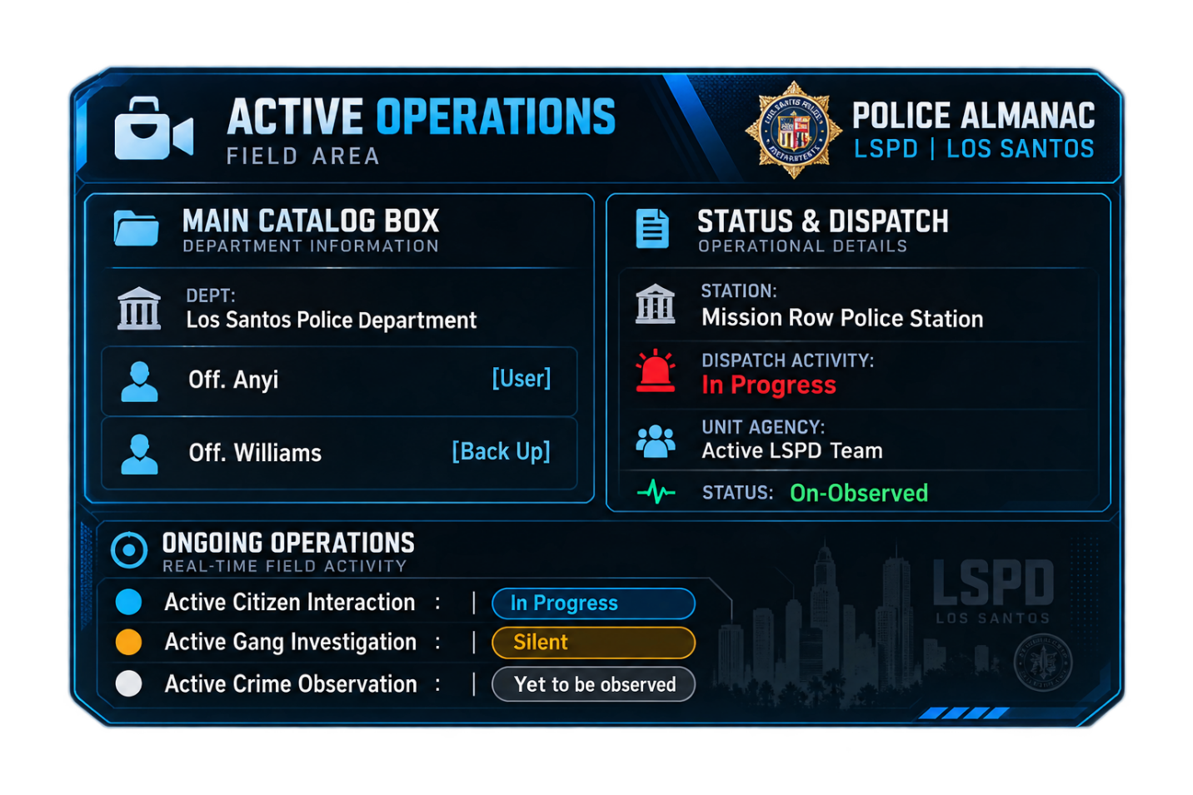

//This should be the Design and Display in the Framework, this should be updated visually and fetched from the status and lively shown the real status display during the player’s duty

//Police Profile

//This is one of the Unique Framework DLC Features of the LSImmersiveLife Project. This consists of profile changeable input in-game of model type and weapon loadout type and vehicle model type and for immersive useful gameplay experience. When, a Player to Select, and Access of the Profile of Player will choose according to the external model type preferences and can be saved at the LSPDImmersiveProfile.xml as its catalog file and as well as player can always use it when starting a gameplay patrol duty. And furthermore when the player chooses its model preference type of profile. It should be supporting the whole police gameplay and behavior, and logic, and world ambient behavior.

A FrameWork Immersive Design FrameWork UI of the Police Profile are under the LSPDProfile, and LSPDProfile will create a profile logic to set for the Player to use the entire preference type of profile

So, for the Whole UI FrameWork of the LSPDPROFILE.CS or Police Profile in the LSImmersiveLife MainUI to Police Main UI and Police Profile UI..

//
Native Title : Police Immersive Profile.
Second title : Choose your Preferred Resources

> Character Model
: Select the Character Model
> Vehicle Model // Typing Input Event

: Select the Vehicle Moel
> Weapon Loadout // Typing Input Event

> Back Up Ped for Citizen Interaction
: Select the Character Model : // Typing Input Event

> Back Up Ped for Dispatch and Crime Activity
: Select the Character Model : // Typing Input Event

> Personal Loudout Weapon
// Create your Weapon Loudout //This allows the User, creating a “LSPolicePersonalWeapon” that exists in the gameplay project path and when a player creates a weapon loadout. It can now have its own collection of empty weapon data and existing in his roulette in-game. Like, the player fetch weapon, or great weapon somewhere and menyoo weapon and then. Now he has collection of collection in his hand, player will save it and it will automatically stores in the provided file

: Save the Current Loadout //Saving to the Player’s personal loudout fle which is system will automatically store inside the provided xml path and to the “LSPoliceWeapon” xml which is system own path and weapon for player who want to save personal weapon rather default.

: Apply the Personal Loadout Weapon
//this to apply to the user current roullete weapon inventory and his inventory gonna fill with the saved personal loudout weapon and can be use in game

: Rewrite the Weapon Loadout : //if the user had the new changes in the weapon and he want to include it in his inventory, the rewrite can update the existing inventory user gonna use for the next gameplay set up

> Save the Profile Data

//This should be automatically saved to the catalog xml in the folder, since the player or user sometimes forgot to save it. But to some measures. It can have the “Save the Profile Data at end of ui selection clicking event design” //for the next gameplay where player moved on to the station and beginning of creating police character and happen to choose and use its selected preferred loudout and character and model vehicle, for next launch of script and selecting the Police Mode, the asset should load fade in especially the vehicle, the vehicle should be fade in and load asset near parked ground near the user rather teleporting to the user, or teleporting the vehicle and user at the same time, and already ride in and floating with vehicle, that is quite idiotic unrealistically

//NPCDatabase

This Database of the NPC Collection Status of the Selected Interaction Citizen by the Police Player and the NPC Database should be able to give Database to the Player requesting from the Dispatcher. From the NPC Gameplay Flow. After a Player fetches a Data Base of the Player. The Framework of the NPCDatabase should show a pleasant screen ui framework near corner of the screen in-game of the Police Player’s Framework and integrate in NPCDatabase and fetched through the Citizen interaction npc and shown the visual image framework. The image shown : //This should be the Design and Display in the Framework, this should be updated visually and fetched from the status and lively shown the real status display during the player’s duty

Skeleton :

┌──────────────────────────────────────────────────────┐
│ 👤 CITIZEN CONTACT POLICE │
│ ACTIVE FIELD RECORD ALMANAC │
├──────────────────────────────────────────────────────┤
│ │
│ CITIZEN RECORD │
│ ──────────────────────────────────────────────── │
│ NAME Jonathan Stevens │
│ CITIZEN ID LSC-2026-PIL-000004 │
│ OCCUPATION Chef │
│ AREA Pillbox Hill │
│ │
│ DOCUMENT & STATUS │
│ ──────────────────────────────────────────────── │
│ DOCUMENT Damaged Identification │
│ CONDITION Questioned │
│ STATUS Inconsistent ID │
│ WARRANT None │
│ │
│ POLICE RESPONSE │
│ ──────────────────────────────────────────────── │
│ RECOMMENDED │
│ Request secondary identification and │
│ document uncertainty. │
│ │
│ CONTACT STATE DOCUMENT CHECK │
└──────────────────────────────────────────────────────┘

Image Visualization :
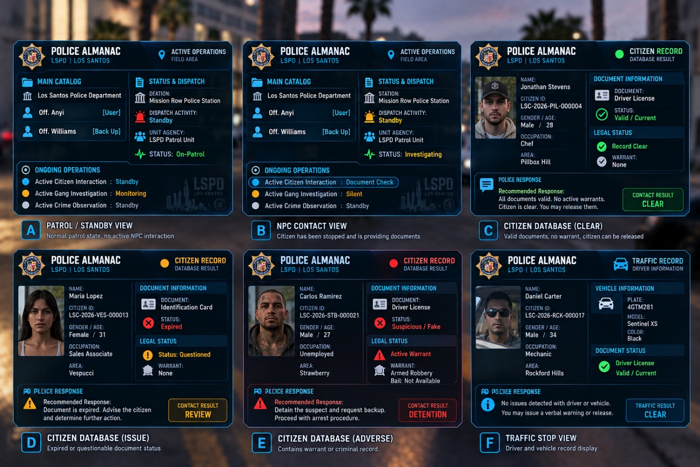

//Audio Response

